**Lab Report #03**

**Experiment Name #** File operation and permission.

**Aim and Objective:**

The purpose of the experiment is to learn how different permission work in Linux operating system. That is how user can control the accessibility through various command of permissions.

* To learn about various permission commands.
* To give protection to one’s file, folder and other belongings.
* To tighten the security.
* To get the best of Linux operating system.

**Experiment:**

**ls -l :**

This command is used to show all the necessary information regarding permission for accessing different file or directory.

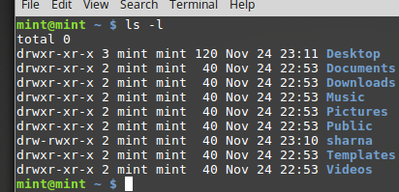

Here we can see that at the left there is various combination of r, w, x. These are the symbols that are used in giving permissions. r stands for read, w for write and x for execution. These permission come in a group of three. There are three general classes of users user(owns the file), group(belong to the group of ownership of file ) and other(everyone else in the world). ‘-’ denotes the normal file and ‘d’ denotes the directory.

**rwx** represents that user can perform read, write and execute a particular file or directory.

**r-x** represents that user can perform read and execute a particular file or directory.

**r- -**denotes that user only can read .

The permission operators are **+, -. =**

**Structure:** [user class symbol] [permission operator] [permission symbol] [,]……….[file name]

**chmod :** chmod command is used to change the permission of a file and directory.

**i) chmod u+x, g-r sharna:**

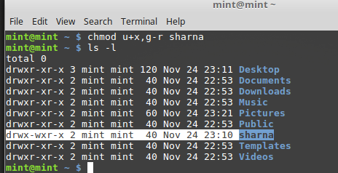1

Here chmod changed the permission and user can execute and group can not read directory sharna.

**ii) ls –l(desktop):**

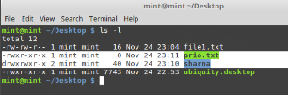

**iii) chmod g-r,o-r sharna:**

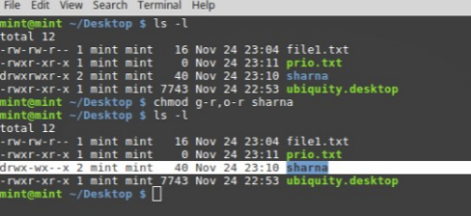

Here chmod changed the permission from rwx to only write and execution for group and only execution for other user.

**iv) chmod ugo=x file1.txt:**

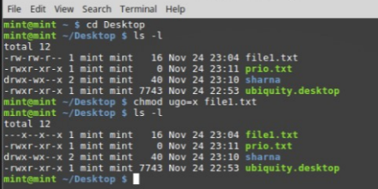

Ugo = x command means giving all users permission to execute. Here ugo equivalent to a.

**Using certain numbers:**

Using certain numbers one can change permission. 4 is for read,2 for write and 1 for execution. 000 denotes no user can access anything. The default permission for file is 644 and for directory 755. By combining different number one can change permission. Here first one for user, second one for group and last one for others

**v) chmod 000 prio.txt:**

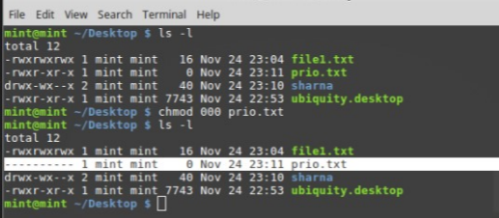

Here no one of ugo can access prio.txt.

**vi) chmod 644 prio.txt:**

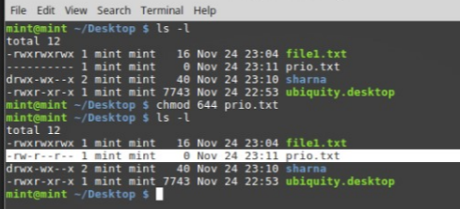

Here user gets permission for read and write, group and others can only read.

**Conclusion:**

Through this experiment of executing different commands I learn the basic commands for file permission of Linux operating system. I use chmod to change the permission to access different file and folder. This helps me to secure the privacy of my files and folders. This is one of the finest applications one can done in linux operating system.